SCHEDULE 2 TO THE DEVELOPMENT CONTRIBUTIONS PLAN OVERLAY
--/--/20--
Proposed C170dare

Shown on the planning scheme map as DCPO2.
DAREBIN DEVELOPMENT CONTRIBUTIONS PLAN 2019
1.0 Area covered by this development contributions plan
This Development Contributions Plan (DCP) applies to all new development within the 16 Charge Areas as shown below.
--/--/20--
Proposed C170dare

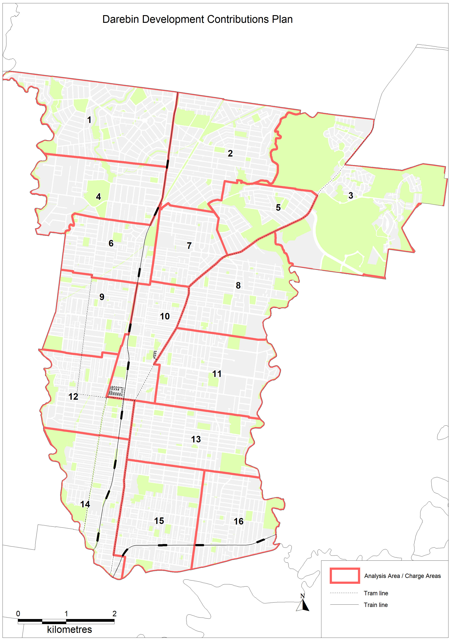

2.0 Summary of costs
--/--/20--
Proposed C170dare

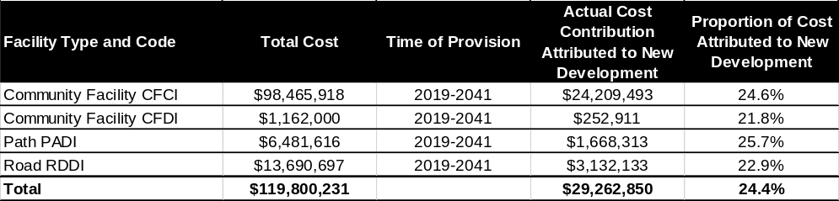
Notes:
This table sets out a summary of the costs prescribed in the Development Contributions Plan. Refer to the Background Document (Darebin Development Contribution Plan 2019) for full details.
This Development Contributions Plan is in addition to any other Development Contributions Plan Overlay Schedule(s) applying to the land as shown in the Planning Scheme.
Darebin City Council commits to delivering the Development Contributions Plan projects by December 31 2041, but may deliver projects earlier. It is likely that projects will be progressively delivered over the Development Contributions Plan period.
Darebin City Council is Collecting Agency and Development Agency for this Development Contributions Plan.
3.0 Summary of contributions
--/--/20--
Proposed C170dare

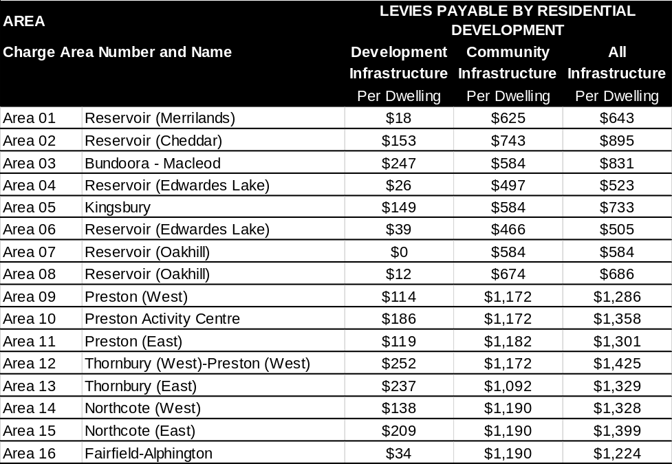

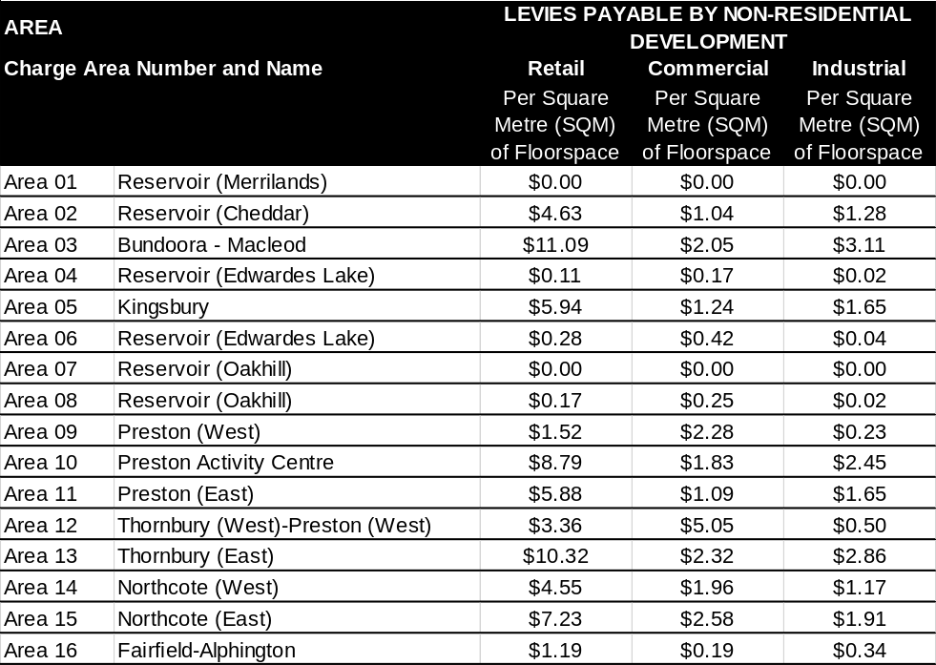

Notes:
Square metres of floorspace (SQM) refers to gross floorspace.
The above listed contribution amounts are current as at 30 June 2019.
Where the Development Contributions Plan provides for a Community Infrastructure Levy of $1,190, Council will charge the maximum amount which will be determined in accordance with Part 3B of the Planning and Environment Amendment (Public Land Contributions) Act 2018. Where the Development Contributions Plan provides for a Community Infrastructure Levy of less than $1,190, that amount will be adjusted on July 1 using the Producer Price Index for Non-Residential Building Construction in Victoria as published by the Australian Bureau of Statistics in accordance with Part 3B of the Planning and Environment Amendment (Public Land Contributions) Act 2018.
The Development Infrastructure Levy will be adjusted annually on July 1 each year to cover inflation, by applying the Consumer Price Index for Melbourne (All Groups) as published by the Australian Bureau of Statistics. All adjustments will occur and take effect from the date of index publication.
A list showing the current contribution amounts will be held at Council’s Planning Department.
Payment of development contributions is to be made in cash. Council, at its discretion, may consider accepting works and / or land in lieu of cash contributions.
Payment of the Development Infrastructure Levy may be required at Subdivision stage or Planning Permit stage or Building Permit stage.
    - Development Infrastructure Levy at Subdivision stage: Payment of the levy is to be made prior to the issue of a statement of compliance for the approved subdivision.
    - Development Infrastructure Levy at Planning Permit stage: Payment of the levy is to be made prior to issue of a building permit.
    - Development Infrastructure Levy at Building Permit stage where no planning permit is required: Payment of the levy is to be made prior to issue of a building permit under the Building Act 1993.
Payment of the Community Infrastructure Levy is to be made prior to issue of a building permit under the Building Act 1993.
The Collecting Agency may, at its discretion, agree for payment of a levy to be deferred to a later date, subject to the applicant entering into an agreement under section 173 of the Planning and Environment Act 1987 to pay the levy at an alternative date.
4.0 Land or development excluded from development contributions plan
--/--/20--
Proposed C170dare

No land or development is exempt from this Development Contributions Plan unless exempt by Legislation or Ministerial Direction or Legal Agreement with Darebin City Council or stated below. The following development is exempt from the development contribution:
    - Land developed for a non-government school, as defined in Ministerial Direction on the Preparation and Content of Development Contributions Plans of 11 October 2016.
    - Land developed for housing by or for the Department of Health and Human Services, as defined in Ministerial Direction on the Preparation and Content of Development Contributions Plans dated 11 October 2016. This applies to social housing delivered by or for registered housing associations. This exemption does not apply to private dwellings developed by the Department of Health and Human Services or registered housing associations.
    - Alterations and additions to an existing dwelling.
    - Outbuildings normal to an existing dwelling and fences.
    - Demolition of a dwelling followed by construction of a replacement dwelling on the same land. The exemption applies to the number of dwellings demolished and does not apply to any additional dwelling(s).
    - Reinstatement of a dwelling which has been unintentionally damaged or destroyed.
    - Servicing infrastructure constructed by a utility authority.
    - Darebin City Council delivered projects, building or works.
    - Land with an agreement executed under section 173 of the Planning and Environment Act that explicitly exempts the development from one or more DCP Overlay Schedules due to the development having met its DCP obligations.
    - The construction of a building or carrying out of works or a subdivision that does not generate a net increase in demand units.

